**IT Entrepreneurship for Global Energy**

**Assignment 1**

**Chhotkei Data Analysis**

**A close up of text on a black background

Description generated with very high confidence**

**A close up of a logo

Description generated with very high confidence**



**Submitted to:**

Dr. Ashok Das, Founder, CEO, SunMoksha

Dr. Manish Agrawal, Professor and Dean of ISDS Department

**Prepared by:**

Shruti Pareek

Deepak George

Ganesh Gosavi

Sandeep Kahar

**May 2018**

Table of Contents

1 Introduction 1

2 Total Load Data- Processing and Analysis 2

Data Transformation 2

3 Consumer level Data- Processing and Analysis 4

4 Conclusion 16

LIST OF FIGURES

Figure 1 Monthly Consumption Pattern 2

Figure 2 Total Load by a day of week 2

Figure 3 Total consumption on weekdays vs weekend 3

Figure 4 Week over week consumption pattern 3

Figure 5 Hourly consumption pattern 4

Figure 6 Total Monthly Consumption at Chhotkei village 5

Figure 7 Total Quarterly Consumption at Chhotkei village 5

Figure 8 User level Monthly Consumption at Chhotkei village 6

Figure 9 Outlier User level Monthly Consumption at Chhotkei village 6

Figure 10 Black out day analysis total clusters 7

Figure 11 Black out day analysis cluster 1 8

Figure 12 Black out day analysis cluster 2 8

Figure 13 Black out day analysis cluster 3 9

Figure 14 Black out day analysis cluster 4 9

Figure 15 Popular Maximum-Consumption-hour among all users 10

Figure 16 Popular Maximum-Consumption-hour on weekdays 11

Figure 17 Popular Maximum-Consumption-hour on weekends 12

Figure 18 DB level Black out days 13

Figure 19 DB level daily consumption 14

Figure 20 DB level Maximum consumption hour 15

Figure 21 DB 3 Maximum consumption hour 15

Figure 22 DB 10 Maximum consumption hour 16

# Introduction

Hourly data of energy consumption by Chhotkei village have been provided. Two types of data were provided:

1. Total Load data
2. Energy consumption data for each of the 119 consumers in the village

This report comprises the data processing methods adopted, and graphs created for analysis of energy consumption.

# Total Load Data- Processing and Analysis

Total load data contains hourly consumption by the village, or hourly load recorded on the grid.

## Data Transformation

The sum of hourly load—specifically, 24 hours of load—was calculated to obtain daily load. This data was further used to produce the following visualization. For 2016, data was available only for the month of February, March, April and May. For 2017 data was available for the month of March, April, May, June, September, October and November.

**Monthly Consumption by Chhotkei Village**

In Figure 1 seasonal pattern was observed, with onset of summer season from February to May/June for the year 2016 and 2017, load consumption has increased gradually. There is missing data for the month of July and August in 2016, but September 2017 onwards, with onset of winter monthly load consumption has decreased.

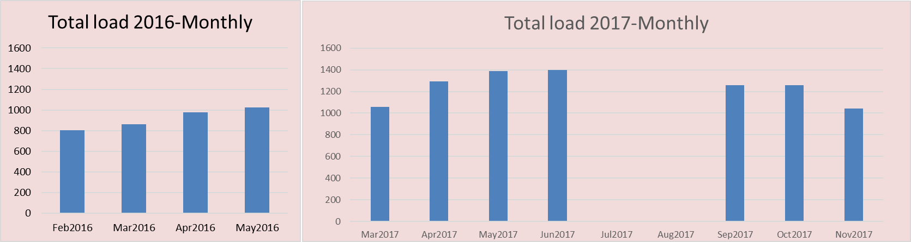

Figure 1 Monthly Consumption Pattern

**Consumption by Chhotkei Village on a day of week**

Figure 2 plots the sum of load recorded for a day of week, and t was observed that Tuesday had the maximum consumption among all weekdays.

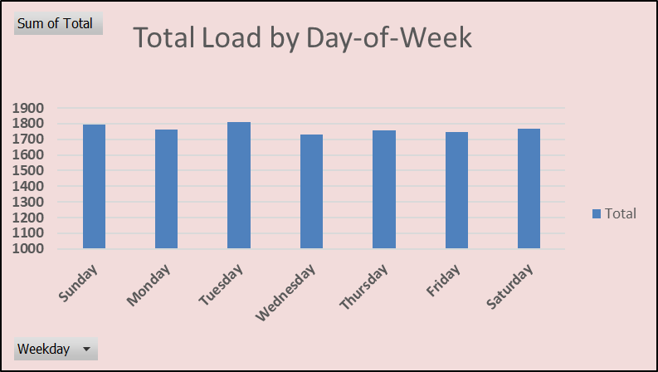

Figure 2 Total Load by a day of week

**Consumption comparison of weekday vs weekend by Chhotkei Village**

Figure 3Figure 2 plots the average of total load recorded on a weekdays vs weekend, and it was observed that on weekend consumption is more compared to a weekday.

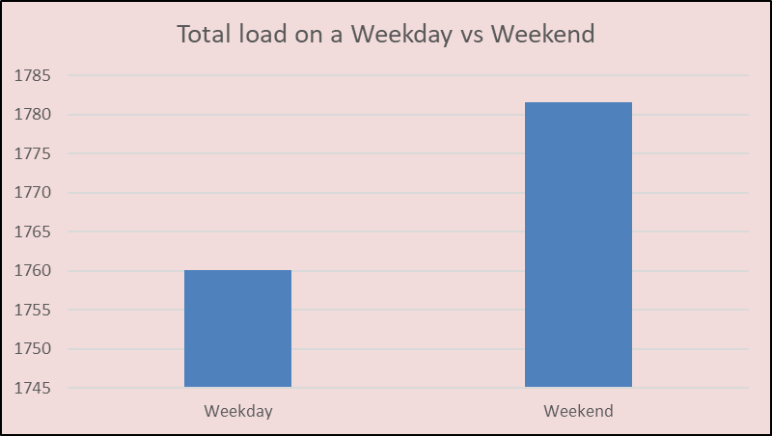

Figure 3 Total consumption on weekdays vs weekend

**Consumption pattern, week over week by Chhotkei Village**

Figure 4Figure 2 plots weekly consumption for the available time, where week 1 is February 2016 and week 47th is November 2017. Weekly consumption has a lot of variance, but expansion in the radar is gradual.

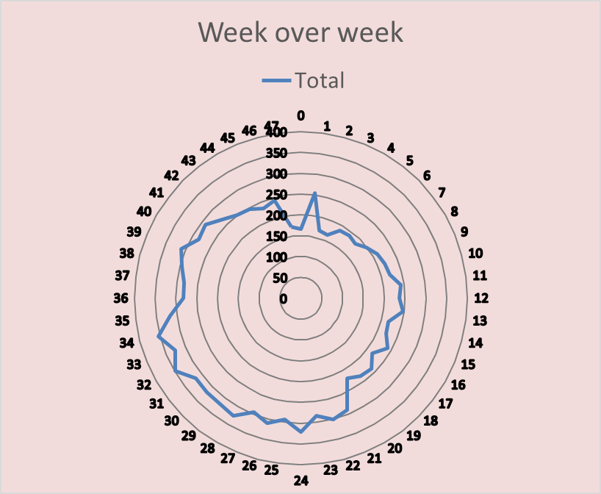

Figure 4 Week over week consumption pattern

**Hourly Consumption pattern by Chhotkei Village**

Figure 5Figure 3Figure 2 plots total consumption on an hour of day, and it was observed, during evening and night, there is high consumption, and morning and afternoon have very low consumption.

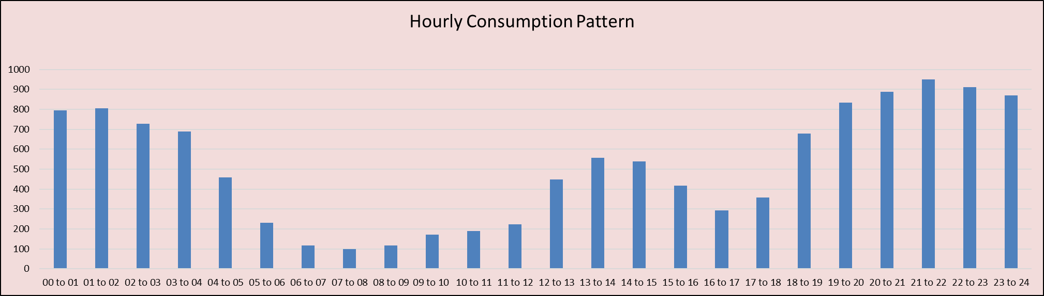

Figure 5 Hourly consumption pattern

# Consumer level Data- Processing and Analysis

There were 119 consumers in the Chhotkei village, comprising of households, streetlights and Community halls. For each of these consumer, hourly consumption form February 2016 to January 2018 was provided.

**Monthly Consumption by Consumers at Chhotkei Village**

In Figure 6Figure 1 total consumption on a monthly basis is shown, it was observed that March 2017 had an unusually high peak, similarly first and second quarter of 2017 had high consumption. Figure 8 shows that six users contributed to the high consumption in March 2017, top two of them are “Nir Jani”, “Shatrugan Nayak” who consumed 276 and 153 respectively. Figure 9 shows the monthly consumption by the outlier consumers, and it was observed they have very similar consumption trend throughout.

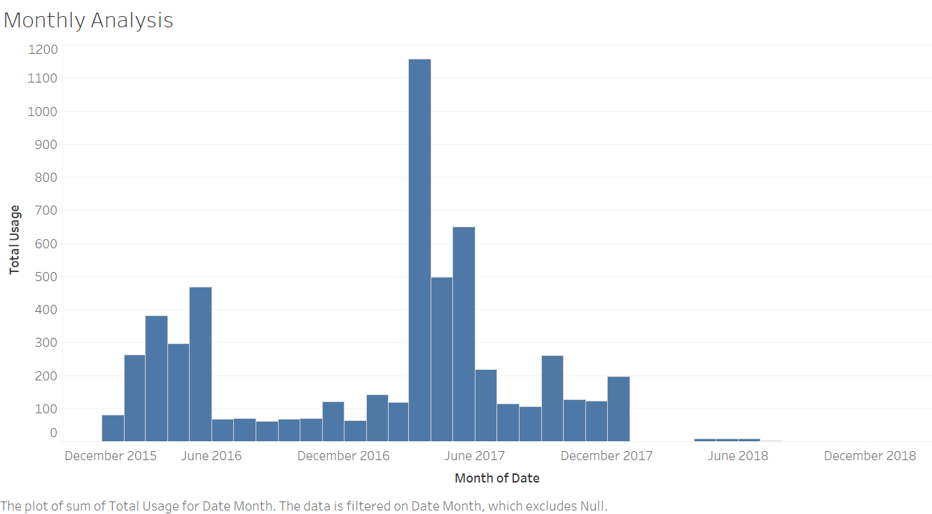

Figure 6 Total Monthly Consumption at Chhotkei village

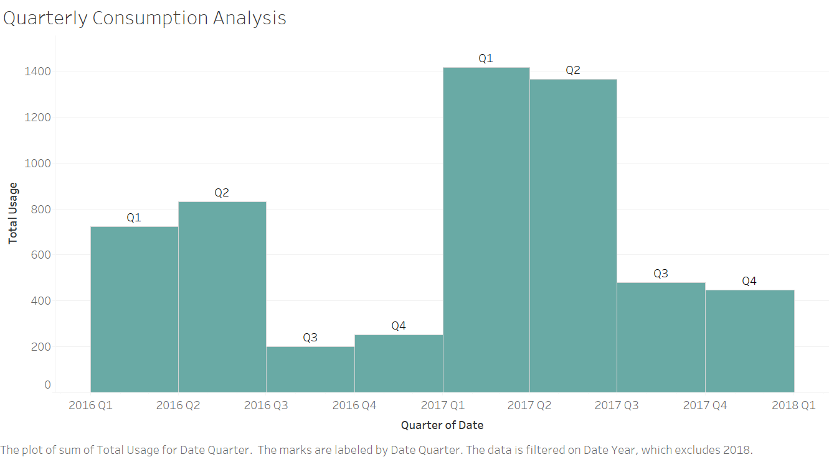

Figure 7 Total Quarterly Consumption at Chhotkei village

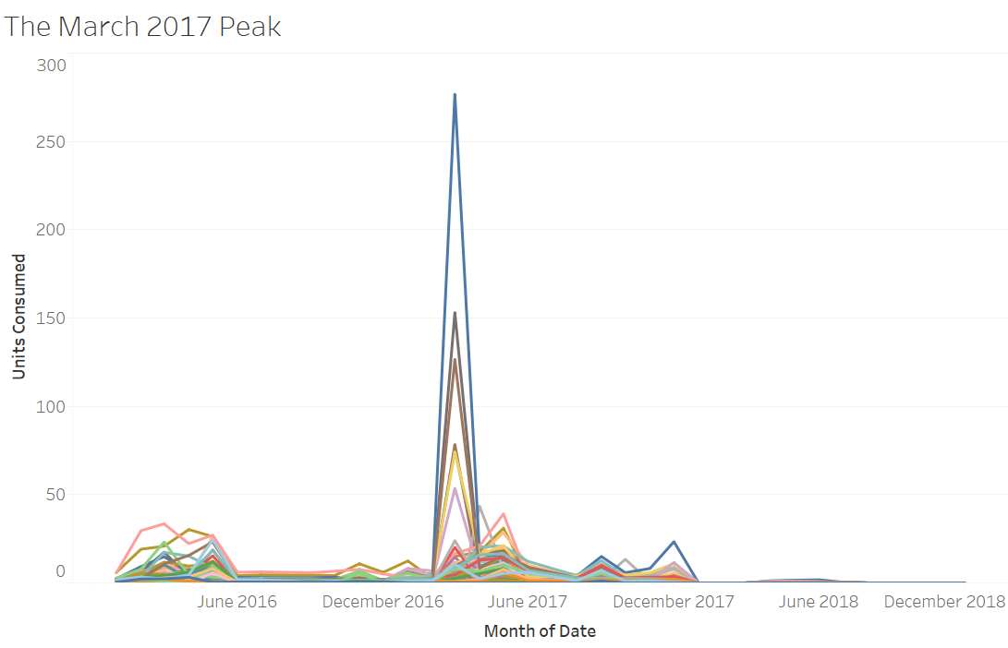

Figure 8 User level Monthly Consumption at Chhotkei village

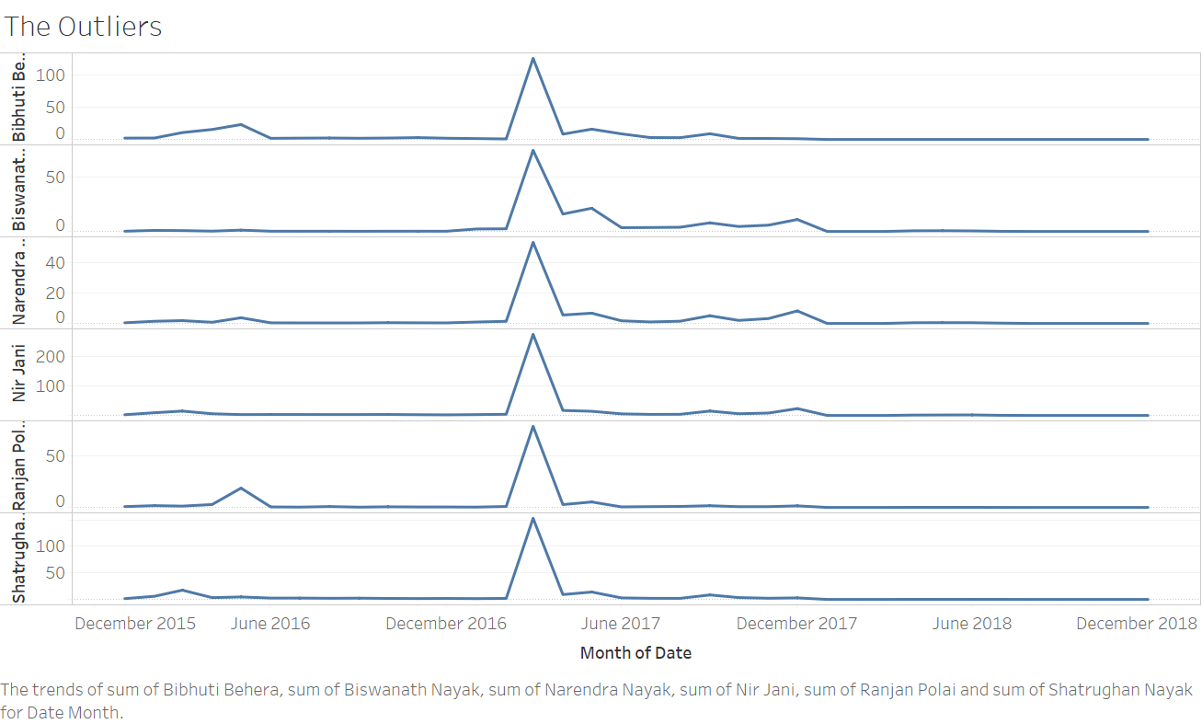

Figure 9 Outlier User level Monthly Consumption at Chhotkei village

**Blackout day Analysis at Chhotkei Village**

On blackout day, there is zero power consumption. Such day were extracted from the data and analyzed.

Figure 10 shows the clusters created based on the number of blackout days experienced by a user. Users are uniformly distributed among four cluster, Cluster 1, 2, 3 ,4 and have about 302, 250, 176 and 101 black out days respectively. Figure 11 Figure 12 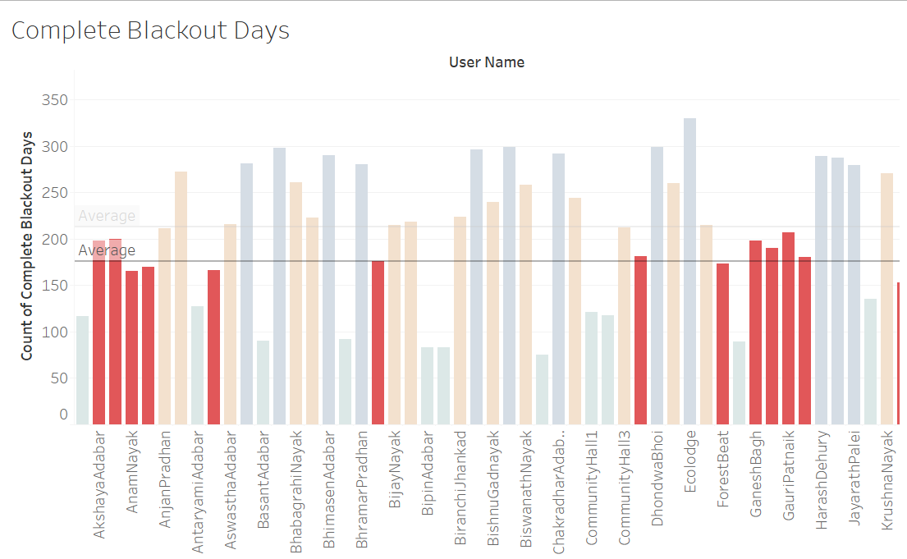

Figure 13 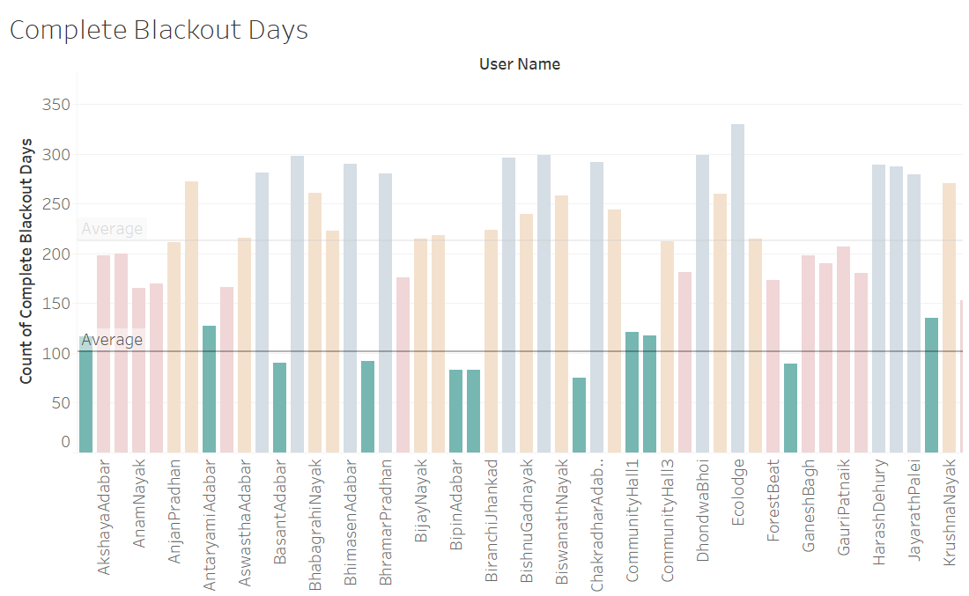Figure 14, shows the number of black out days observed by each user in a cluster.

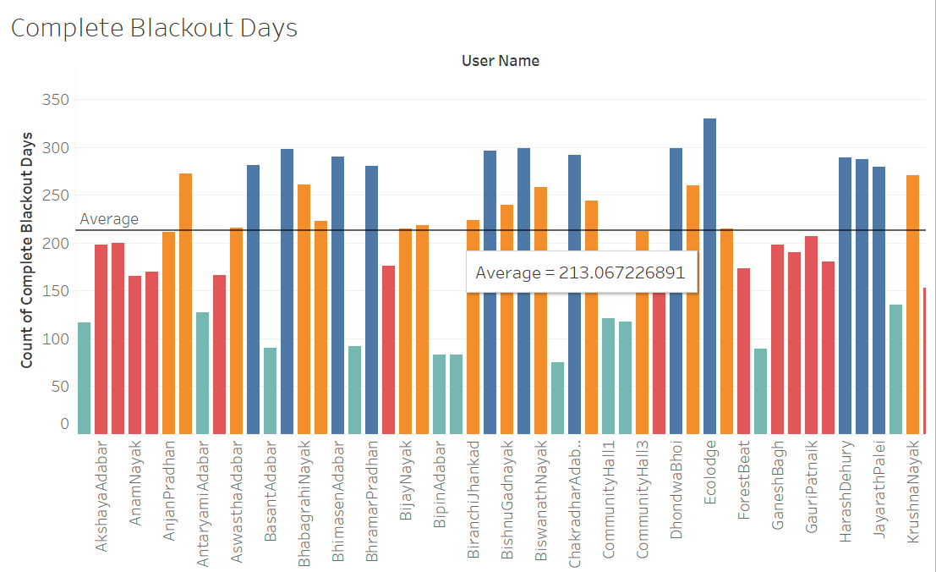

Figure 10 Black out day analysis total clusters

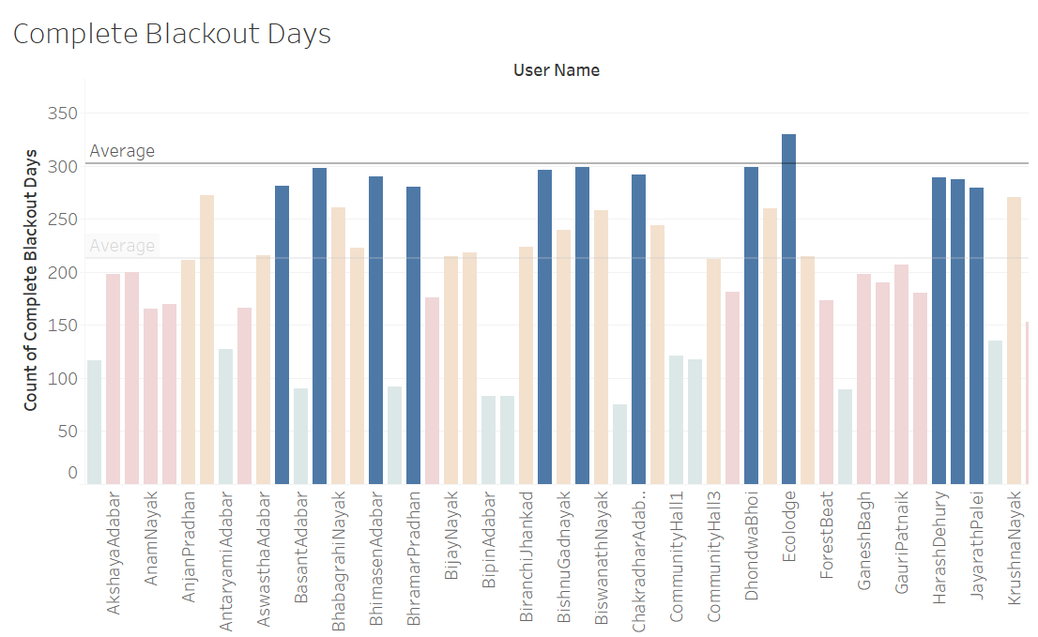

Figure 11 Black out day analysis cluster 1

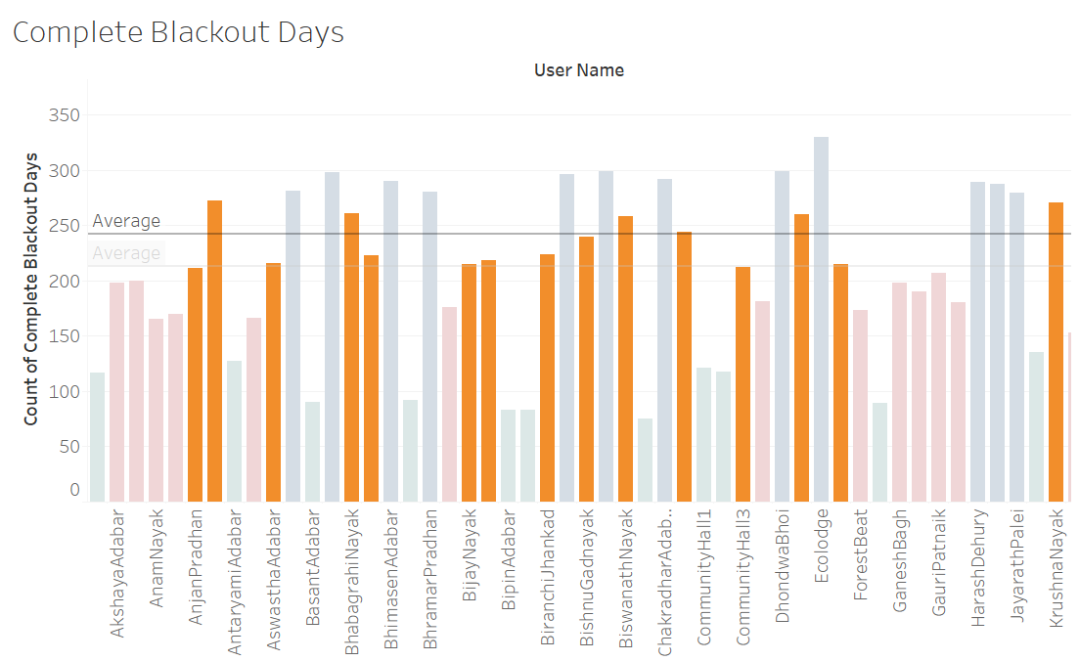

Figure 12 Black out day analysis cluster 2



Figure 13 Black out day analysis cluster 3

Figure 14 Black out day analysis cluster 4

**Maximum consumption hour analysis at Chhotkei Village**

Maximum-consumption-hour is the hour of the day during which the highest consumption ware observed. Such Maximum-consumption-hour were extracted for each day for all consumers and analyzed.

Figure 15 shows the percent of times, an hour was the maximum-consumption-hour, it was observed that midnight, 12 AM to 2 AM has been the maximum consumption hour for most of the user. In other words, most of the users, will be consuming their highest consumption of the day at these hours. These hours are the crucial hours of operations for the infrastructure. Also, certain schemes or offers can be designed with keeping these hours in mind. Figure 16 Figure 17 shows the popular maximum consumption hour on weekdays and weekends respectively.

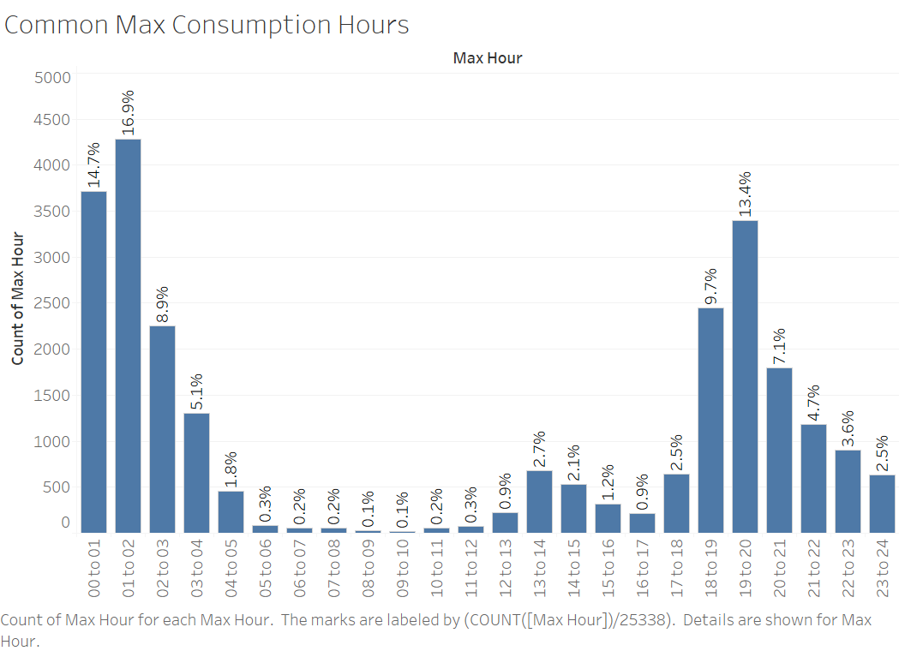

Figure 15 Common Maximum-Consumption-hour among all users

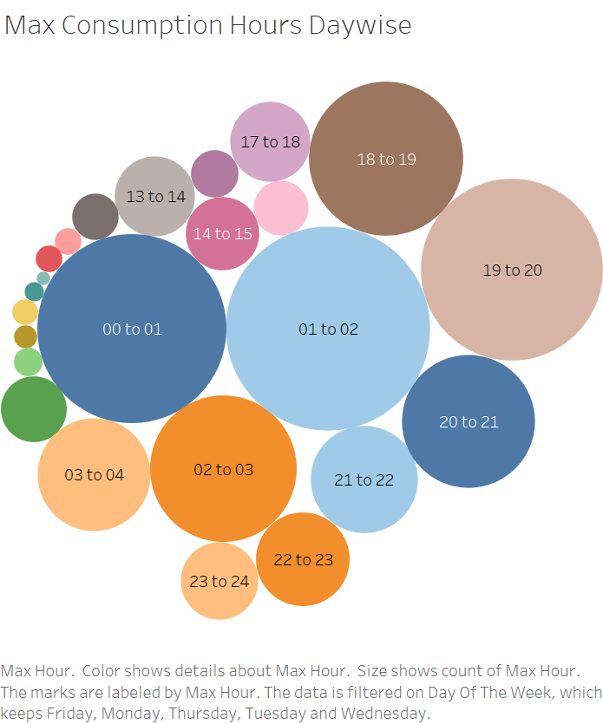

Figure 16 Common Maximum-Consumption-hour on weekdays

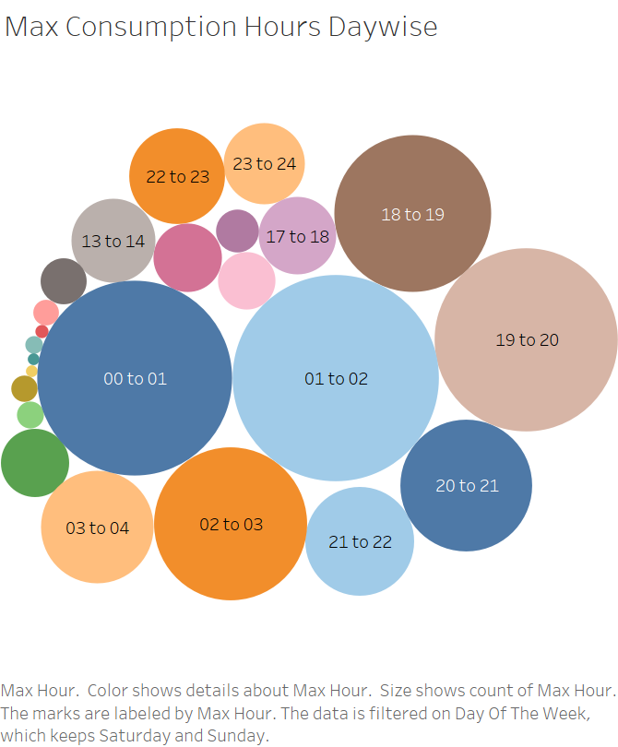

Figure 17 Common Maximum-Consumption-hour on weekends

**DB level analysis- Daily consumption and Blackout days**

There are 12 DBs and each DB is connected to certain number of users thus each DB plays a significant role in the infrastructure. Figure 18Figure 2 shows the number of blackout days for each DB, and DB 3 and DB 4 had the most blackout days. Figure 19 shows average daily consumption for each DB, it was observed that DB 3, DB 10 and DB 4 have the maximum consumption on a daily basis. This analysis, showcases the DBs which are critical to the system, based on the consumption pattern and number of users tied to it. Additionally, it also highlights the scope of improvement for the DBs, which often run into Blackout days.

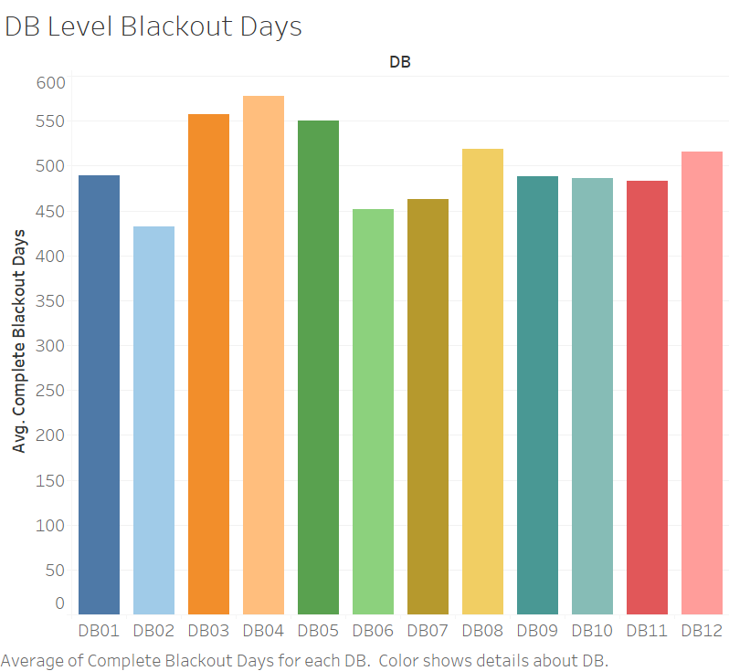

Figure 18 DB level Black out days

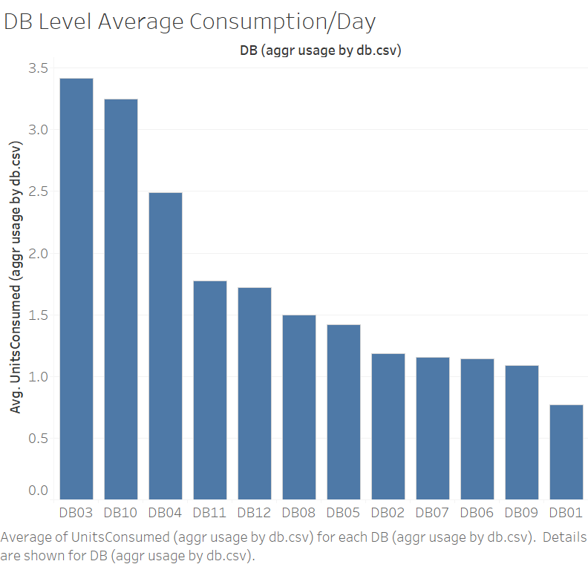

Figure 19 DB level daily consumption

**DB level analysis- Maximum Consumption hour**

In order to find the crucial hours of operations at the DB level, Figure 20 shows the number of times, an hour of the day was maximum-consumption-hour for all DBs and it was observed that 5 PM to 6 PM was the maximum consumption hour for most of the DBs. However, this graph may not provide DB specific crucial hour of the day, since for each DB, the peak hours are observed to bes different. For instance, Figure 21 shows that for DB3 (with highest daily consumption) 1 PM to 2 PM is the maximum hour of consumption, most of the times. However, Figure 22 shows that for DB 10, 5 PM to 6 PM was the maximum hour of consumption for most of the days.

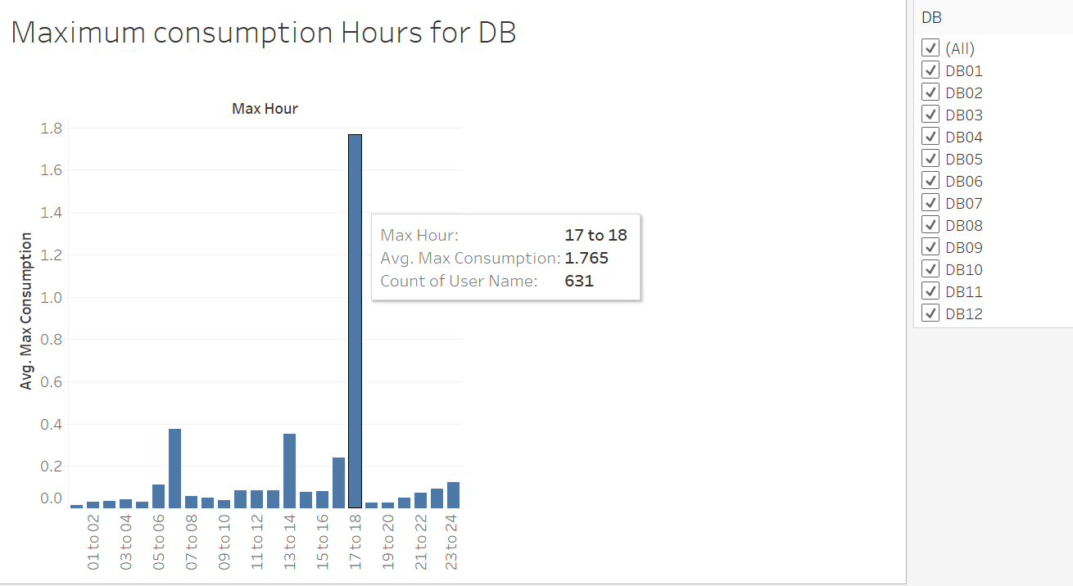

Figure 20 DB level Maximum consumption hour

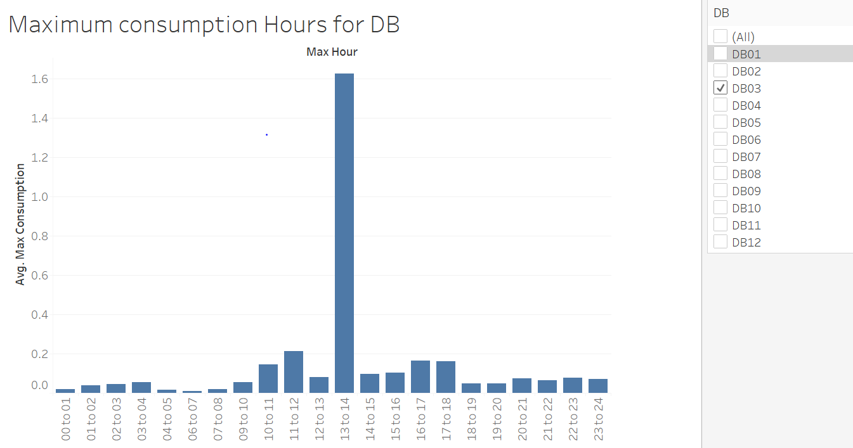

Figure 21 DB 3 Maximum consumption hour

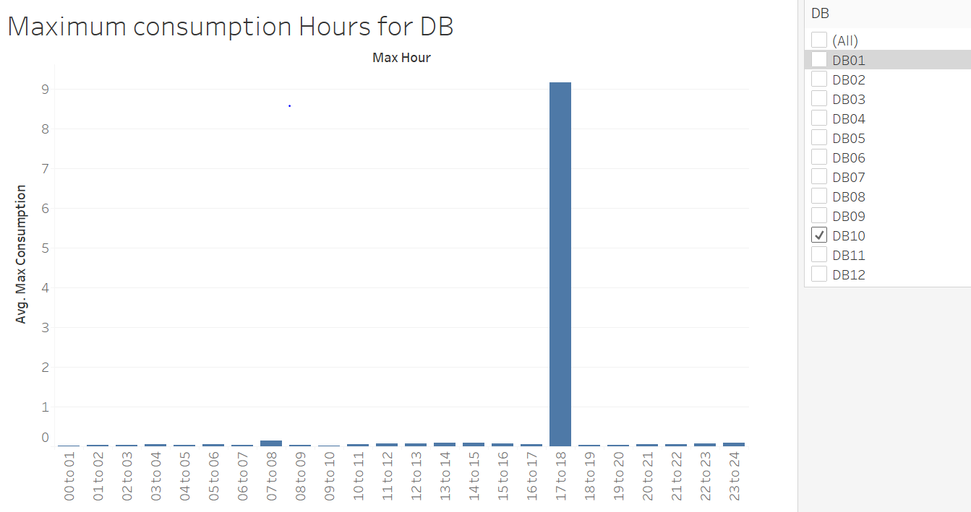

Figure 22 DB 10 Maximum consumption hour

# Conclusion

Overall analysis suggests during Midnight and evening (5 to 6 PM) consumption is high. Blackout days should be reduced to provide better infrastructure to consumers. Each DB has a different pattern of consumption during the day and shall be improvised based on consumption patterns. A similar presentation of this document can be accessed here: <https://youtu.be/oArI4LTavNM>